Published on Croner-i (https://app.croneri.co.uk)
Health and Safety > Fire > Science of Fire and Suppression: In-depth

Science of Fire and Suppression: In-depth

Summary
Fire is a chemical reaction brought about by the combining of fuel and oxygen and the application of sufficient heat to cause ignition. When these three elements are brought together fire will occur. This is known as the “fire triangle”.
Fire can cause injury and death in a number of ways. Direct contact with flames causes burns, but in many fire situations the more dangerous aspect is the risk of asphyxiation, which can be caused by the toxic fumes and smoke produced when fires burn and the consumption by fire of available oxygen in a room.
A key aspect of modern fire safety legislation is to prevent fires from occurring. The fire risk assessment and management of fire safety should be aiming to achieve this but to do so it is necessary to have an understanding of what fire is and how it occurs, as this topic describes.

Employers' Duties
The responsible/appropriate person or duty holder has duties under the relevant legislation, these being the:
- Regulatory Reform (Fire Safety) Order 2005
- Fire (Scotland) Act 2005 / Fire Safety (Scotland) Regulations 2006
- Fire and Rescue Services (Northern Ireland) Order 2006 / Fire Safety Regulations (Northern Ireland) 2010.
Under the relevant legislation, the responsible/appropriate person or duty holder must take the necessary preventative measures that are reasonable to avoid or combat fire risks at source and eliminate risks from dangerous substances, where this is reasonable to do so.

Employees' Duties
Under the relevant fire safety legislation, employees must co-operate with the responsible/appropriate person or duty holder to ensure the workplace is safe from fire and its effects, and must not do anything that will place themselves or other people at risk.

In Practice

The Dangers of Fire
The dangers of fire fall mainly into two areas: heat and the products of combustion. Not everyone is aware, however, that it is usually not the heat from a fire that kills: the most common cause of death is inhaling smoke and the hot or toxic products of combustion. In a fire, the heat can reach up to 1000°C and will exceed 300°C within the first 2 minutes. At these temperatures, even “fresh” air can kill with one breath.

The Combustion Process
For combustion to take place, heat, fuel and oxygen are required. Heat in fire terms is often misinterpreted as “flame”, since heat can be manifested not only in flame but by friction, electrical current and chemical reaction. In general terms, however, the presence of heat (commonly as flame) is the means by which the combustion process starts.
For combustion to take place, all three elements of the reaction must be in place, as follows
- Heat as a means of moving the molecules so as to achieve increase in pressure or expansion and more heat.
- Oxygen in order to achieve “oxidation” which may be oxygen in the air or within the substance itself.
- Fuel or a material to burn.
This is often called the fire triangle.
If any one of these three elements is missing, combustion cannot occur and fire will not start, or will cease if it already has started. This gives rise to two important applications: fire prevention and firefighting. Both rely on removing one or more of these items. Prevention usually involves ensuring that fuel and heat are always kept apart. Firefighting usually involves removing the oxygen or the heat.
It is important to remember that if one element is removed from this “triangle” and the fire goes out, and if the element is then re-applied, the fire will re-start. For example, a CO₂ extinguisher works by displacing the oxygen. If the “cloud” of CO₂ gas is allowed to disperse before the material on the fire has cooled, the oxygen is re-applied and the fire starts up again.
It is worth considering that there also needs to be sufficient contact time between the heat, oxygen and fuel to set off the reaction and establish the chemical process that we commonly call “fire”.

The Nature of Burning
It is a misconception that it is the solid matter in materials that burns. The act of burning a material involves heating it to a temperature at which it becomes, or gives off, a gas — it is then the gaseous form that burns. As an example of this, timber or wood is perceived to burn readily. However, it is not the solid wood that ignites; it is the heating of the solid to an extent that it becomes a gas, and the igniting of the gas, that causes the material to burn. The temperature required to raise a material to a gaseous extent sufficient to support combustion is known as the “flame point”.

Temperature Requirements
For the combustion process to continue and be sustained, there must be sufficient temperature to generate sufficient gas which, when ignited, will generate further heat and provide more gas to ignite — this is called “fire point”. Some materials, such as phosphorous, are so volatile that they have very low flash and fire points. Specific measures therefore have to be taken to prevent these materials from spontaneously combusting.
Most materials will only undergo spontaneous combustion when the temperature in the room has risen to a level that heats all elements simultaneously to a point where all the materials concerned will ignite and then continue to sustain combustion. This is often referred to as “flash point”.

Spontaneous Combustion
“Spontaneous combustion” is a phenomenon where materials will give off sufficient gaseous emissions to support ignition and combustion simultaneously. Spontaneous combustion arises when a material originally stored at normal ambient temperature becomes hot enough for combustion to occur without an external ignition source. This is known as “self-heating”.

Fire Growth and Development
If all the conditions are present for a fire to start, it will grow and develop in the following way.
- Ignition. An ignition source is applied to a combustible material. At this stage, depending upon the flammability of the material which is first ignited, a fire may burst into flame in a matter of minutes, or it may smoulder for hours before completely catching alight.
- Growth. If left unchecked in the presence of a plentiful supply of fuel and oxygen, the fire is likely to grow rapidly. When materials burn, they provide new sources of ignition by heating the other combustible materials present to temperatures at which they will also ignite. A growing fire is likely to get hotter as it spreads to include more combustible materials.
- Flashover. This occurs when what appears to be a comparatively small fire has been left to heat up all of the combustible materials in an enclosed room to such a degree that everything “bursts” into flame at once.
- Continued development. Once flashover has occurred, a fire will continue to grow but temperatures will increase more slowly. As the fire grows, however, it may spread to nearby rooms, compartments or even other buildings, and as the fire takes hold in each new area, it will go through the growth and development stages already described.
- Dying stages of a fire/back draught. If the fire occurs in a room where the oxygen will eventually be used up, eg in a room where all doors and windows are firmly closed, the fire will be dampened and will eventually go out. However, if the door is opened on such a fire or it is otherwise ventilated while it is still smouldering, a back draught will occur. The person opening a door on such a fire is at great risk of being killed or severely injured.

Spread of Fire
Fire is spread from one part of a building to another by the transfer or transport of heat. Heat transport occurs from one material to another, or from one area to another, on the basis of transfer from a place of higher temperature to a place of lower temperature.
There are three basic methods of transferring heat.
- Conduction.
- Convection.
- Radiation.

Conduction
Conduction can take place with materials in solid, liquid and gaseous states, but normally only in the solid and liquid forms. Energy in the form of heat is transported from one particle to another at a rate dependent upon the “thermal conductivity” of the material. The ability of a material to conduct heat may have importance in a fire situation, eg heat may be transferred from a fire in one building by a steel beam, to another building remote from the fire. Thermal conductivity differs between substances. Metals are good conductors of heat and carbonaceous materials (ie wood) are not.
Heat Conduction
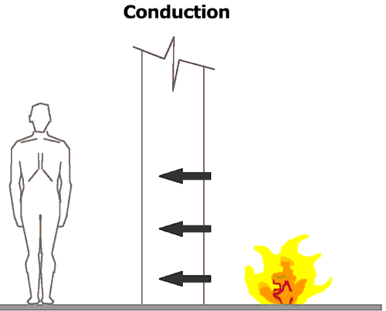

Convection
Convection occurs only in gases and liquids.
As the molecules are heated, they vibrate or move together more quickly, causing a rise in the pressure of the substance. This causes these particles to become less dense and lighter, so they rise. As they rise, they displace cooler particles which then become heated and displace others, setting up a circulation or current within the substance. It is the movement of the molecules that passes heat around the substance, and this will continue until the entire substance has reached a uniform temperature.
Heat Convection
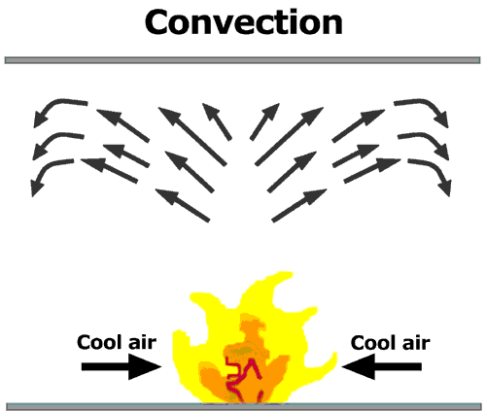
Convection is important since it is the transmission of heat via gases (eg hot smoke) along uncompartmented passages and voids, which often leads to ignition in areas remote from the fire, and the “smoke logging” (contamination by smoke to the extent that it restricts vision, movement and respiration of occupants) of spaces in which no fire initially exists.
Spread of fire by convection is very dangerous and causes the greatest number of deaths and injuries.

Radiation
For the purposes of basic fire safety, the phenomenon of radiation is simply demonstrated by the output and effect of an electrical radiant fire or the sun. The output of heat is carried by “electromagnetic wave motion” and the effect is either transmitted through, absorbed or reflected by the receiving material. Radiation is a common cause of igniting the materials that lead to a fire and a common means of igniting further materials once a fire has started.
Heat Radiation
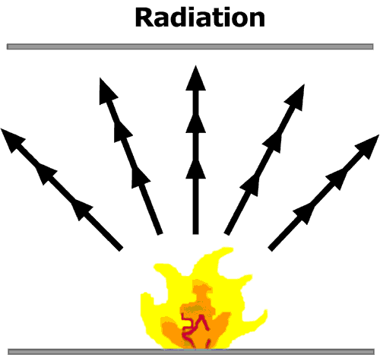

Heat Absorption and Transfer
As part of their basic properties, all materials possess the ability to absorb and transfer heat — albeit at different rates. Heat is produced by chemical means (eg by burning oil in a lamp) or physical means (eg by rubbing two pieces of wood together).
Heat can also be transferred from one place to another, normally from a place at a higher temperature to a place at a lower temperature. This is the process that leads to “heating” and “cooling” and the extent to which a material will absorb heat is measured by its “specific heat capacity”.
Specific heat capacity is the property of a material by which the heat required to raise it through 1°C measured in joules/kilogram (J/kg): all materials can be classified using this as a reference. For example, aluminium has a specific heat capacity of 900J/kg, copper 400J/kg and water 4200J/kg.
The specific heat capacity of water is extremely high. This makes water a useful medium as a cooling agent with which to extinguish fires.

Spread of Smoke
As a fire develops, the gases inside the room containing a fire heat up, expand and create pressure, causing smoke to be forced out of the compartment (ie the room). Smoke and combustion gases can quickly spread through a building, usually ahead of the fire, presenting great danger to anyone still in the building.
Smoke and gases can obscure vision, cause confusion and panic and have an unpleasant effect on eyes, nose, throat and lungs. It is estimated that 50% of deaths in fires are attributable to the incapacitation of persons due to gases and smoke. For this reason, it is vital to consider the spread and effect of the smoke created by the fire as it burns, as well as considering the spread of the fire.

Common Causes of Workplace Fires
The cause of fire in the workplace often tends to be associated with the nature of the workplace and activities undertaken. A fairly common cause is faulty electrical wiring (including overloading) or equipment. Another significant cause is hot working, generally associated with building work involving cutting or welding or the use of tar boilers in roofing work. Arson is perhaps the most significant and insidious source.
Other causes of fire include:
- smoking
- faulty electrical wiring or overloaded circuits
- static discharge
- unusual sources such as lightning
- flame — by direct contact or by radiated or conducted heat, eg lights or other hot surfaces resting on combustible materials
- friction — often from poorly maintained equipment — or impact
- spontaneous combustion
- hot surfaces
- blocked ventilation holes in equipment
- exothermic reactions — substances which, when mixed, give off a large heat of reaction
- engines
- incorrectly stored or used flammable substances
- pyrophoric materials — those which will ignite solely in the presence of oxygen, with no other applied heat source
- incorrectly stored flammable waste
- dust explosions.

Means of Controlling Fire
The concept of the fire triangle can be used to show the basic methods of controlling fire.
Fire Triangle
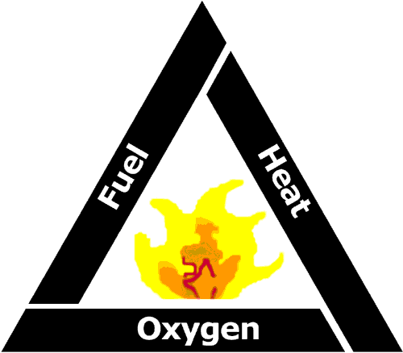
Removing one of these constituent elements will collapse the reaction and the combustion process will cease or be extinguished.
This is commonly achieved by:
- starvation — removing or limiting the fuel
- smothering — removing or limiting the oxygen
- cooling — removing or reducing the heat.

Starvation
Here, the fuel source is removed. For example, shutting off a gas supply on a cooker; capping an oil-well head; stemming the flow from an oil tank.
Removing Fuel
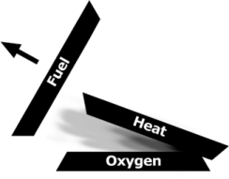

Smothering
If the oxygen is prevented from participating in the chemical reaction, then the process will cease. Generally, this can be achieved by covering the fire with a layer of “air-tight” material, such as a fire blanket or foam. When fires involve some metals where oxygen is contained within the material, it may be necessary to introduce a chemical agent to offset the reaction. These types of fires are normally specialist and require specific risk management and loss-prevention techniques. Therefore, specialist assistance should be sought.
Removing Oxygen
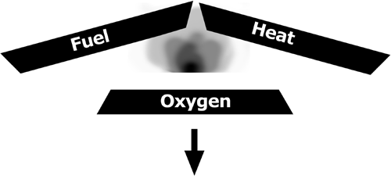

Cooling
The most common form of fire extinction is the cooling of the reaction, or removal of the heat. This is normally achieved by spraying water onto the fire (although this usually has the effect of partially smothering the reaction too) or by simply turning-off the heat source.
Removing Heat
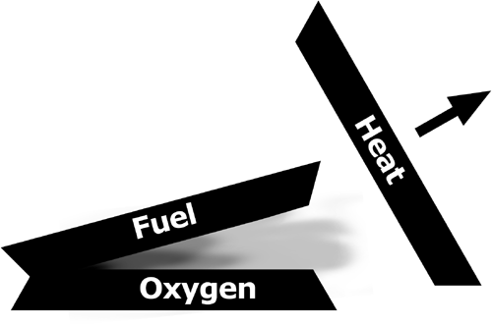

Classification of Fires
BS EN 2:1992 Classification of Fires is the European Standard that categorises fires into distinct classes according to the material undergoing combustion. It does not define a particular class of fire involving an electrical risk.
The Standard classifies different types of fires which can be defined in terms of the nature of the fuel. The scheme of classification is particularly useful when selecting extinguishers as a means of fighting fire and when selecting the appropriate variety of portable, fire-fighting equipment for premises.
The scheme is also a useful way of simplifying written and spoken reference to the different types of fire based on the fuel involved.
Classification is as follows.
Category | Type of Fire | Description
Class A | Fires involving solid materials, usually of an organic nature, in which combustion takes place with the formation of glowing embers. | These are the most common of all fires, as Class A materials are present in all premises and occupancies (eg wood, paper, textiles, etc).
Class B | Fires involving liquids or liquefiable solids. | These fires fall into three main categories.  - Fires in liquids of appreciable depth, ie more than ¼ inch.  - Spill fires or running/flowing fires in liquids of no real depth.  - Pressurised flammable liquid fires from damaged vessels or product lines.
Class C | Fires involving gases. | With fires involving gases there will always be a possibility of explosions occurring due to ignition of an unburned gas cloud. For example, most liquefied gases are heavier than air and will search for the lowest point to congregate, eg cellars, basements, drains or sewers.  The hazard, unknown to those around, could spread some distance from its origin.
Class D | Fires involving metals. | A typical metal fire would involve the likes of magnesium, sodium, aluminium, phosphorus or other similar metallic elements. The extreme intensity with which the combustion process take place manifests itself in the production of intense light (which could possibly cause irreparable damage to the eyes) and large volumes of highly toxic smoke.
In addition to these categories of fire, two other classifications are provided for the purposes of portable extinguisher selection, as follows
- Class F fires: fires involving cooking oils or fats. Such fires differ from conventional liquid fires due to the high temperatures involved. For any flammable liquid to burn, the temperature must exceed the flash point (the temperature above which the liquid will ignite when an ignition source is applied).
- Electrical fires: fires involving electrical equipment or apparatus.

List of Relevant Legislation
- Localism Act 2011
- Fire Safety (Scotland) Act 2005
- Fire and Rescue Services Act 2004
- Health and Safety at Work, etc Act 1974
- Building Regulations (Northern Ireland) 2012
- Fire (Scotland) Act 2005 (Relevant Premises) Regulations 2012
- Building Regulations 2010
- Fire Safety (Employees’ Capabilities) (England) Regulations 2010
- Fire Safety Regulations (Northern Ireland) 2010
- Fire Safety (Scotland) Amendment Regulations 2010
- Fire and Rescue Services (Northern Ireland) Order 2006
- Fire Safety (Scotland) Regulations 2006
- Regulatory Reform (Fire Safety) Order 2005
- Building (Scotland) Regulations 2004

Further Information

Publications

Home Office Publications
The following are available from www.gov.uk.
- A Short Guide to Making Your Premises Safe from Fire
- Fire Safety Risk Assessment — Animal Premises and Stables
- Fire Safety Risk Assessment — Educational Premises
- Fire Safety Risk Assessment — Factories and Warehouses
- Fire Safety Risk Assessment — Healthcare Premises
- Fire Safety Risk Assessment — Large Places of Assembly
- Fire Safety Risk Assessment — Means of Escape for Disabled People
- Fire Safety Risk Assessment — Offices and Shops
- Fire Safety Risk Assessment — Open Air Events and Venues
- Fire Safety Risk Assessment — Residential Care Premises
- Fire Safety Risk Assessment — Sleeping Accommodation
- Fire Safety Risk Assessment — Small and Medium Places of Assembly
- Fire Safety Risk Assessment — Theatres, Cinemas and Similar Premises
- Fire Safety Risk Assessment — Transport Premises and Facilities

British Standards
The following are available from the BSI Shop.
- BS 9999:2017 Fire Safety in the Design, Management and Use of Buildings. Code of Practice
- BS ISO 19706:2011 Guidelines for Assessing the Fire Threat to People
- PAS 79:2012 Fire Risk Assessment. Guidance and a Recommended Methodology

Scottish Government Publications
The following publications are available from the FireLaw section of www.scotland.gov.uk.
- Practical Fire Safety Guidance for Care Homes
- Practical Fire Safety Guidance for Healthcare Premises
- Practical Fire Safety Guidance for Medium and Large Premises Providing Sleeping Accommodation
- Practical Fire Safety Guidance for Small Bed & Breakfast and Self-Catering Premises
- Practical Fire Safety Guidance for Small Premises Providing Sleeping Accommodation
- Technical Standards for Compliance with the Building Standards (Scotland) Regulations 1990
- The Evacuation of Disabled Persons from Buildings

Northern Ireland Publications
For Northern Ireland, fire safety documentation can be downloaded from: www.nifrs.org/firesafe

Organisations
- British Automatic Fire Sprinkler Association
- http://www.bafsa.org.uk
- The British Automatic Fire Sprinkler Association is the principal UK trade association for the fire sprinkler industry. It provides information on the benefits of sprinkler systems.
- Fire Industry Association (FIA)
- http://www.fia.uk.com
- The FIA is a trade association formed by the merger of two leading associations within the fire protection industry — Fire Extinguishing Trades Association, the trade association of companies responsible for the manufacture and maintenance of portable fire-fighting equipment, and British Fire Protection Systems Association established, the co-ordinating body for the UK fire systems industry.
- Fire Protection Association (FPA)
- http://www.thefpa.co.uk
- The FPA is the UK’s national fire safety organisation. It provides a range of fire safety audit and fire risk assessment services.
- Fire Service College
- http://www.fireservicecollege.ac.uk
- The Fire Service College provides facilities for both practical and theoretical fire-fighting, fire safety and accident emergency training.

Source URL: https://app.croneri.co.uk/topics/science-fire-and-suppression/indepth
Copyright © 2019 Croner-i Ltd and/or its affiliates. All rights reserved.

