Fire doors explained: A beginner’s guide

To put it simply, fire doors save lives.
These specialist doors are tested against the elements and purpose-built to withstand roaring fires for as long as possible.
Fire doors have a few vital safety features and really can be the difference between life and death.
If you own a commercial or non-domestic property, there are strict regulations and guidelines to follow, ensuring the doors can withstand certain heats. Fire doors can also have massive advantages for private properties.
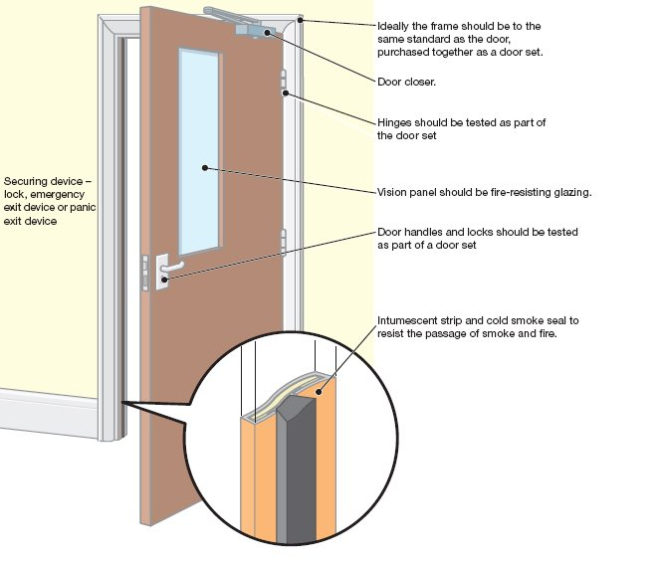

Features of fire doors
Here are some of the key features to look out for in terms of both domestic and commercial use:
- Fire doors are made up of various components. The door itself is usually made from a solid timber frame, but they can sometimes be covered again in fire-resistant glass.
- Around the edges of the door will be the intumescent seal, which is designed to expand when temperatures reach beyond 200°C to seal the gaps between the door and frame.
- For a private premises, it is advised to install fire doors where the risk is most imminent, for example the kitchen, or rooms which house lots of electrical devices. If your property is a new build, it should have been subject to regulations ensuring certain doors are fire doors – check this with the developer.
- For commercial or non-domestic properties, liability lies with whoever is deemed the ‘responsible person’ for that property or the employer. For example, the owner of the property, or the person in control of the property for trade reasons would be responsible.
- Thorough risk assessments must be carried out and it is advisable to get professional help with all fire-safety-related regulations. There is more to fire safety than just fire doors; escape routes, lighting, warning systems and equipment checks are also required.
- When you’re choosing a door it’s important to know what the different specifications mean. The FD code shows how many minutes of fire a door can withstand, for example an FD20 has been tested to withstand 20 minutes. The most common of the codes is FD30.
- Around 42% of deaths during house fires are not from direct contact with the flames, but the consumption of smoke. With this in mind, keep an eye out for a doorset with cold smoke seals. These should be within the intumescent seal.

Fire Door Checklist: 5 steps for responsible persons

If you’re a building owner or manager or otherwise responsible for fire safety in your premises then you should find the five-step guide to checking your fire doors below invaluable.
One of those steps is ensuring that doors can close properly. The consequences of failing to do so were tragically illustrated in 2012 by the death of 23-year-old student Sophie Rosser. An inquest heard that her death could have been avoided if a self-closing fire door in the block of flats in Canary Wharf had closed properly when fire broke out.
According to research by Fire Door Safety Week, more than a third (36%) of building users admitted to wedging open or removing an automatic mechanism for closing a fire door because the door has annoyed them. While 46% of people (especially over 55s) said they’d have the common sense to close an open fire door, 20% admitted that they’d leave it open.
“We need to up the ante on fire door safety,” said Hannah Mansell, spokesperson for Fire Door Safety Week. “The rates of fire deaths and casualties are reducing, but there are still an average of 25 fatalities or injuries from building fires every day.
“Fire doors are a crucial first line of defence in many of these fires, and yet they remain a significant area of neglect. Fire doors are often the first thing to be downgraded in a specification, mismanaged throughout their service life, propped open, damaged and badly maintained.
“Ten years on from new laws being introduced, fire door failure is still a consistent feature of prosecutions under the Fire Safety Order. Just this year alone we know of hundreds of thousands of pounds of fines and prison sentences for people who have failed to meet their fire safety responsibilities.
“We’re finding faulty fire doors in buildings of every type – from council flats to care homes, hospitals to hotels, private rented homes to publicly listed company HQs. We want to see organisations and building owners in every sector pledge support to Fire Door Safety Week and take action today to check their fire doors.”
