**CERTIFICATE IN FIRE AND RISK MANAGEMENT**

**E2 Element 2: Principles of fire and explosion**

1. What are the three elements of the fire triangle?
2. How would you describe combustion?
3. True or False
4. Combustion occurs when fuel is in a gaseous state.
5. Gases, fluids and liquids are the three states of fuel
6. As a solid heats up it converts into a gas
7. Liquids with a high surface-to-volume ratio vaporize and combust more easily and rapidly
8. Energy can be electrical, mechanical and radioactive
9. Liquids burn by turning into a vapour first, this is known as vapour phase reaction.
10. There are four phases which combustion or fire goes through including ignition and growth
11. The decay phase is the first phase of combustion
12. Heat energy is transferred from one object to another, or is transferred to another form of energy, but never disappears.
13. Fire is normally the result of an endothermic reaction
14. Oxidising agents *although not necessarily combustible themselves, may readily liberate oxygen, or be the cause of oxidation of other materials. As a result, they may start or contribute to the start of a fire and increase the violence of a fire.*
15. Give a brief description of the following terms

|  |  |
| --- | --- |
| Term | Description |
| Flashpoint |  |
| Fire point |  |
| Auto ignition temperature |  |
| Vapour Pressure |  |

1. Which of the following features are associated with liquefied petroleum gas?
2. Heavier than air
3. Stored as a liquid under pressure but converts to a gas when released
4. Can expand over 100 times when released from a pressured container
5. Inert
6. Highly flammable
7. Corrosive
8. May lead to loss of consciousness
9. Can lead to cold burns
10. Fire Classes

|  |  |
| --- | --- |
| **Fire Class** | **Example Fuel Sources** |
| A |  |
| B |  |
| C |  |
| D |  |
| F |  |

1. Give two features of a building’s design which could contribute to increased smoke movement
2. Outline the three methods of heat transfer and how the design of a building could contribute to each.
3. Which method of heat transfer is shown here? 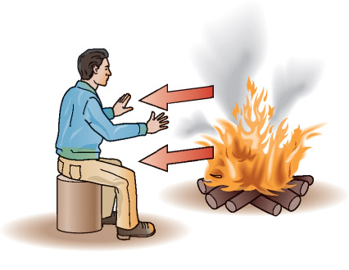
4. Which of the following is not a method of heat transfer? Radiation, Insulation, Convection & Conduction.
5. In which of the following are the particles closest together? Solid, Liquid, Gas
6. How does heat energy reach the Earth from the Sun? Radiation, Convection & Conduction.
7. Which is the best surface for reflecting heat radiation? Shiny white / Dull white / Shiny black / Dull black
8. Which is the best surface for absorbing heat radiation? Shiny white / Dull white / Shiny black / Dull black
9. How would you describe a Flashover?
10. Describe the term backdraft.
11. What is the difference between detonation and deflagration?
12. Give three factors needed for there to be a dust explosion.
13. Describe how a boiling liquid expanding vapour explosion could occur and give two effects of such an explosion.
14. Explain the term inerting and how it can contribute to the prevention of explosions.
15. Name the following devices which can be used to reduce the risk of explosions.

A B

 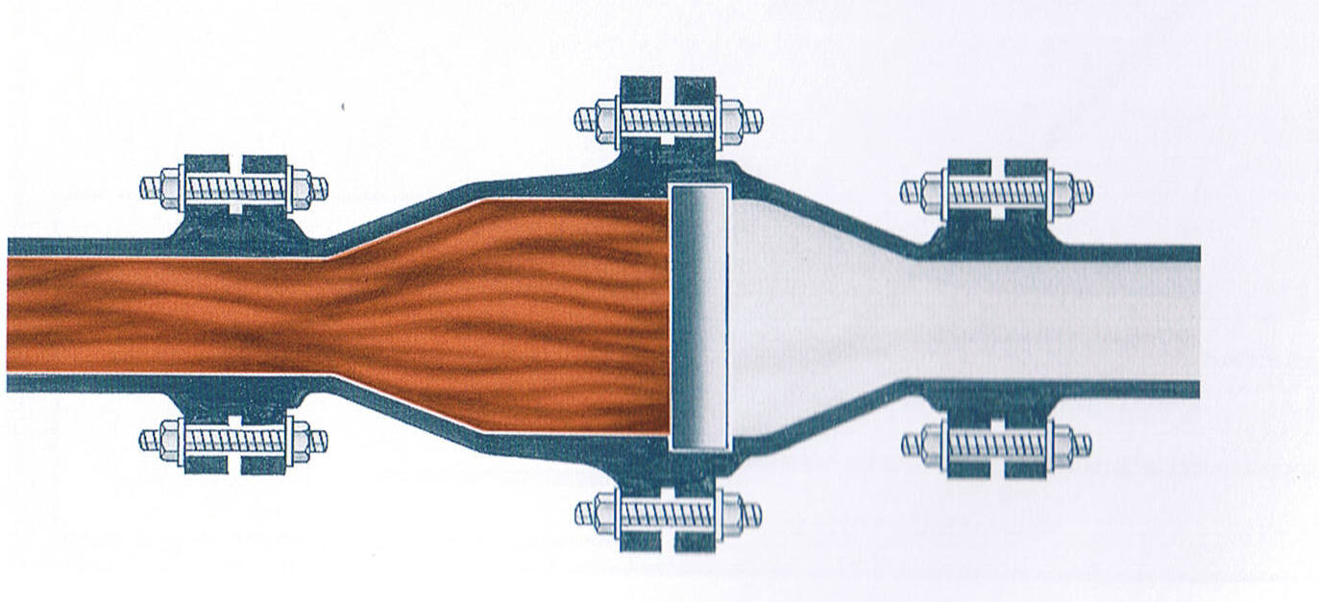

C D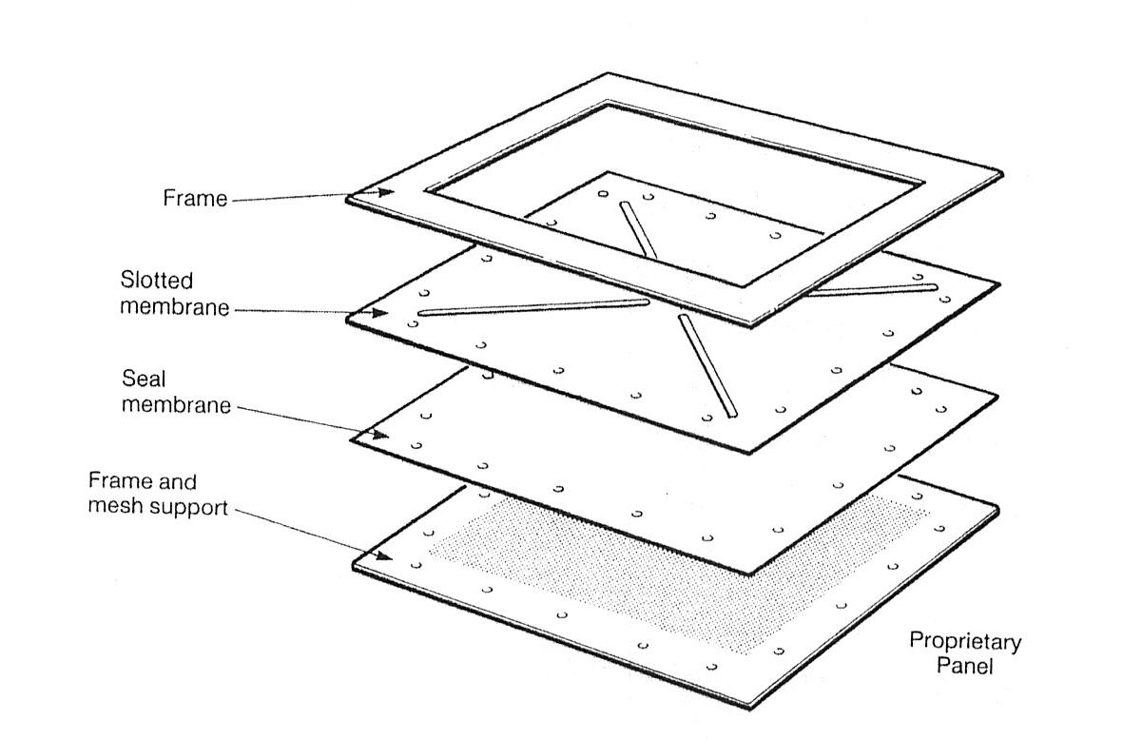 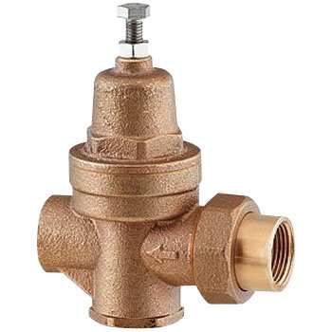

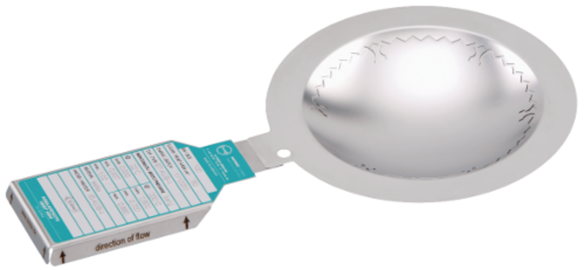E F

